1. 
2. 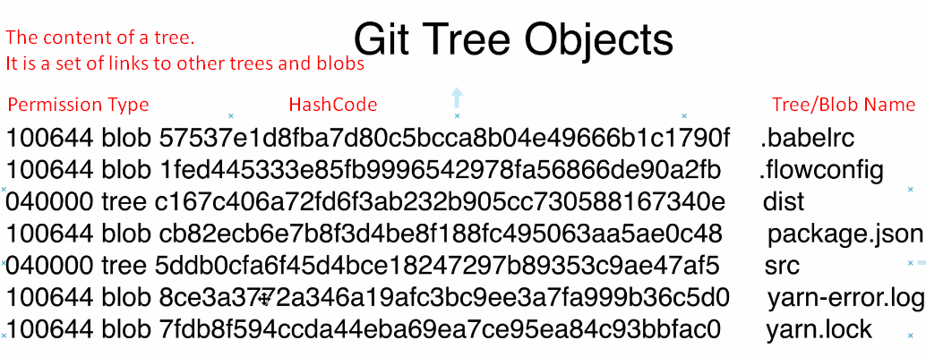
3. Let’s talk about the permission type in the above slide in the first column.
4. There is total 6 kinds of permissions but 1st two are mostly commonly used permissions.
5. 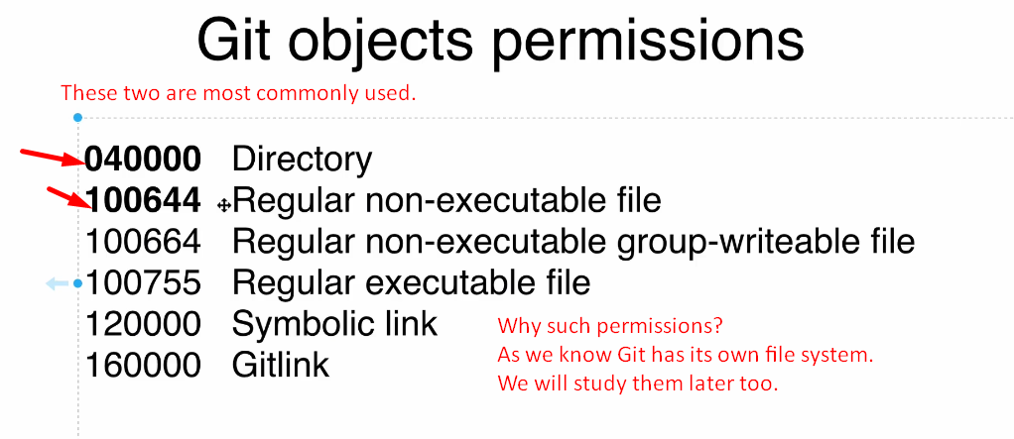
6. Why those permission types?
   1. **Answer**: As **Git** has its own file system. So Git is independent of the underlying file system.
   2. 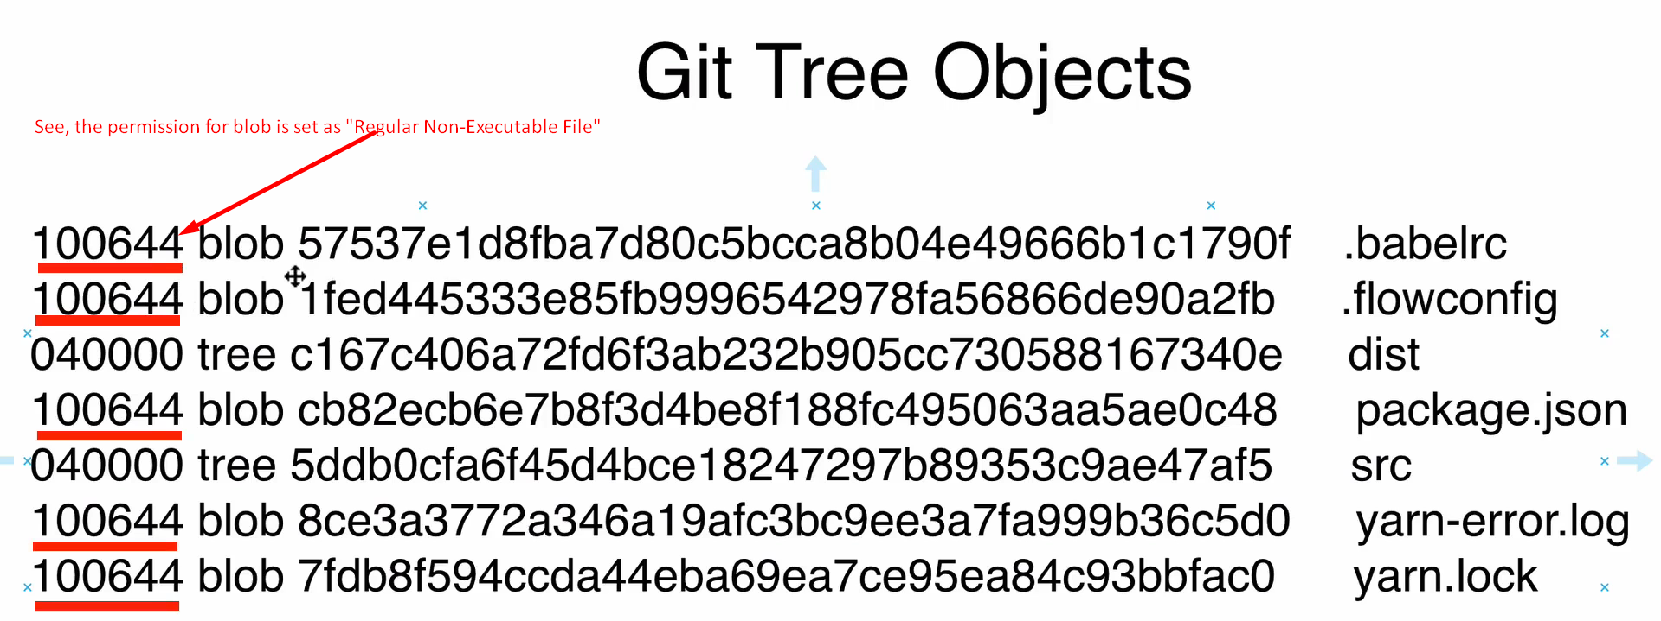
   3. Text

      Description automatically generated
7. In the next lecture, let’s see the Git Low-Level Command **git mktree**.